SEMESTER TWO
Papers written by Australian Maths Software

YEAR 11

MATHEMATICS APPLICATIONS
Units 1 & 2
2016
REVISION 1
Section Two
(Calculator–assumed)

Name: _________________________________

Teacher: ________________________________

TIME ALLOWED FOR THIS SECTION

Reading time before commencing work: 10 minutes
Working time for section: 100 minutes

MATERIAL REQUIRED / RECOMMENDED FOR THIS SECTION

To be provided by the candidate
Standard items: pens, pencils, pencil sharpener, highlighter, eraser, ruler.

Special items: drawing instruments, templates, notes on up to two unfolded sheets of A4 paper, and up to three calculators approved for use in examinations.

IMPORTANT NOTE TO CANDIDATES
No other items may be taken into the examination room. It is your responsibility to ensure that you do not have any unauthorised notes or other items of a non–personal nature in the examination room. If you have any unauthorised material with you, hand it to the supervisor before reading any further.

To be provided by the supervisor
Question/answer booklet for Section Two.
Formula sheet retained from Section One.
Structure of this examination

 | Number of questions available | Number of questions to be answered | Working time (minutes) | Marks available | Percentage of exam
Section One  Calculator—free | 6 | 6 | 50 | 52 | 35
Section Two  Calculator—assumed | 10 | 10 | 100 | 98 | 65
Total marks |  |  |  | 150

Instructions to candidates

1. The rules for the conduct of this examination are detailed in the Information Handbook. Sitting this examination implies that you agree to abide by these rules.

2. Write your answer in the Question/Answer booklet.

3. You must be careful to confine your responses to the specific questions asked and to
follow any instructions that are specific to a particular question.

4. Spare pages are provided at the end of this booklet. If you need to use them, indicate in the original answer space where the answer is continued i.e. give the page number.

5. Show all your working clearly. Your working should be in sufficient detail to allow your answers to be checked readily and for marks to be awarded for reasoning. Incorrect answers given without supporting reasoning cannot be allocated any marks. For any question or part question worth more than two marks, valid working or justification is required to receive full marks. If you repeat an answer to any question, ensure that you cancel the answer you do not wish to have marked.

6. It is recommended that you do not use pencil, except in diagrams.

7. The Formula Sheet is not to be handed in with your Question/Answer booklet.

Section Two: Calculator–assumed 98 marks

This section has ten (10) questions. Attempt all questions.
Working time : 100 minutes

Question 7 (7 marks)

(a) Find the mean and the standard deviation of the following set of data. (4)

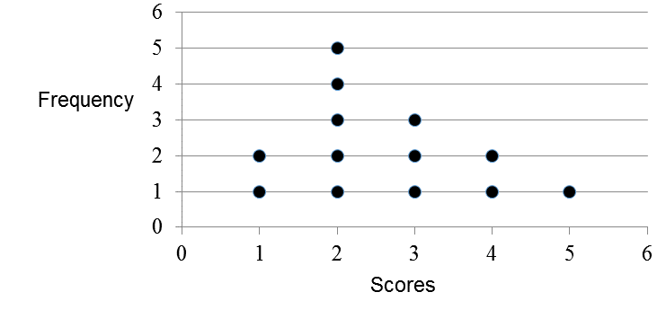

(b) Write down the mean and standard deviation of the following set of data. (3)

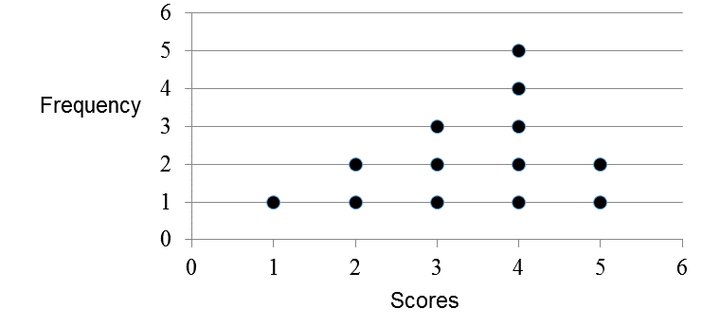
Question 8 (8 marks)
(a) (i) Find the mean and standard deviation of the scores 5, 6, 7. (1)

(ii) Find three different numbers that have a mean of 10 and a standard deviation of
0.8164966. (2)

(iii) Find x such that the mean of the scores 3, 3, x, x is 4. (2)

(b) Sketch two sets of symmetrical data 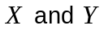on the one axis such that
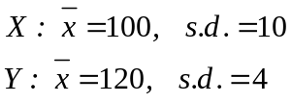
Your sketch does not have to be to scale. (3)

Question 9 (5 marks)

(a) The hours worked for four workers for one week is shown in the table below.

 | Monday | Tuesday | Wednesday | Thursday | Friday
Penny | 8 | 8 | 8 | 8 | 8
Bob | 2 | 3 | 3 | 3 | 2
Kate | 5 | 5 | 6 | 6 | 8
Suzie | 2 | 2 | 3 | 3 | 3

The amount paid per hour for each worker is as follows

Penny | 25
Bob | 18
Kate | 26
Suzie | 16

(i) Use a matrix product to determine what the workers cost the company for each day. (3)

(ii) How much did it cost the company to pay its workers for this week? (2)
Question 10 (9 marks)

(a) Jim earns $20 per hour for 30 hours a week and also works 2 hours overtime at time and a half regularly per week.
James earns $16 per hour for a 40 hour week.

Who earns the most and by how much? (4)

(b) Peg earns $1200 a week after tax.

Her expenses are
Rent $350 per week
Car payment and petrol $250 per week
Food $120 per week
Entertainment $40 per week
Phone $40 per month
Electricity $90 per month
Gas $60 per month

(i) What are Peg’s total expenses per week? (3)

(ii) What can Peg save per year if she spends about $400 on clothes per year? (2)

Question 11 (7 marks)

(a) Which is the better buy

Coles online $2.70 for 375 grams of Weet-Bix
OR
Woolworths $4.50 for 1.2 kg? (3)

(b) A CD player is marked at $130. The store had a sale and there was a discount of 20%.

(i) What is the discount price of the CD player? (2)

The store had bought the CD player for $90.
(ii) What was the percentage profit for the discounted price? (2)

Question 12 (16 marks)

(a) Find the area of the shape below. The shape consists of semi-circles on the sides of an
equilateral triangle with sides 10 cm. (4)

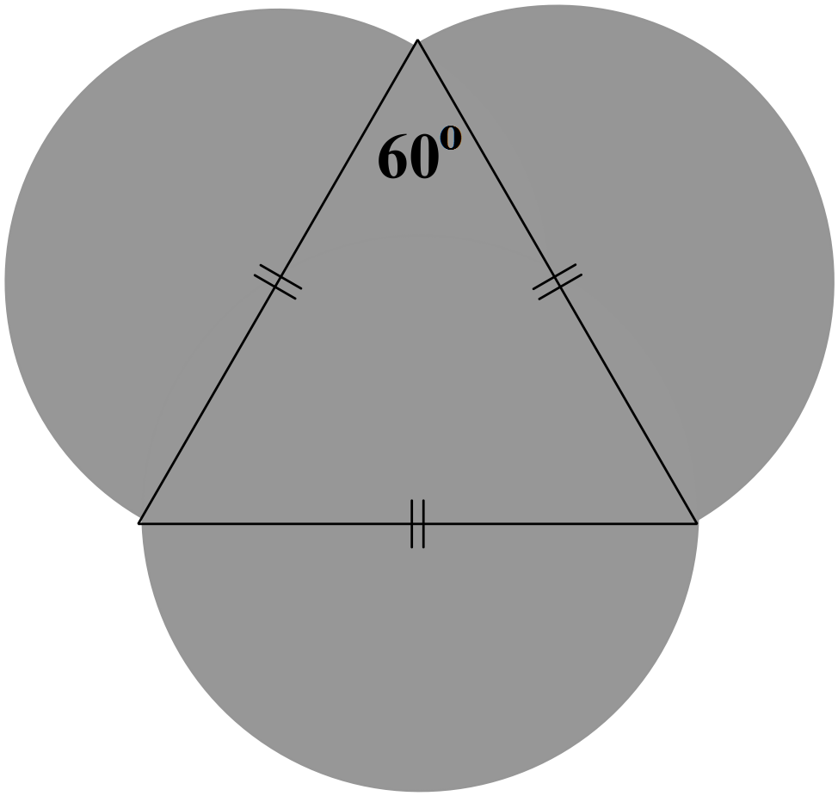

(b) The shape below consists of a cube of side 20 cm, and a cone of height 20 cm.
Determine the volume of the shape. (3)

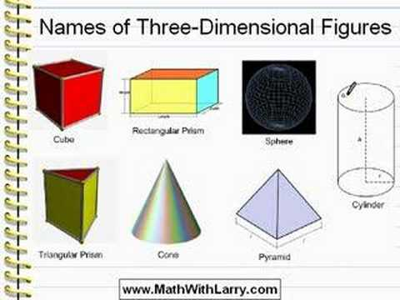

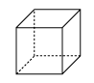

(c) The boot of a car is 1.5 m wide, 1 m deep and 0.5 m high. Pam bought a mop that is 1.7 m long.

Will it fit in the boot of the car? (3)

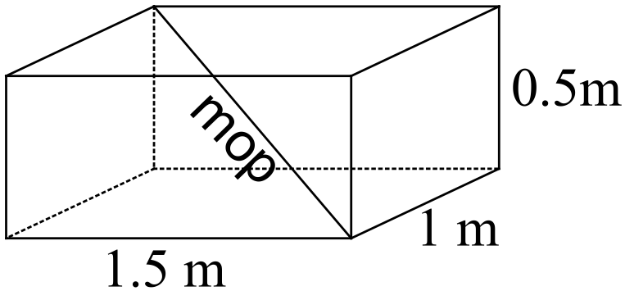

(d) A man’s shadow was 2.5 m long at the same time that the shadow of a tree measured 4.5 m.

If the man was 1.8 m tall, how high was the tree? (3)

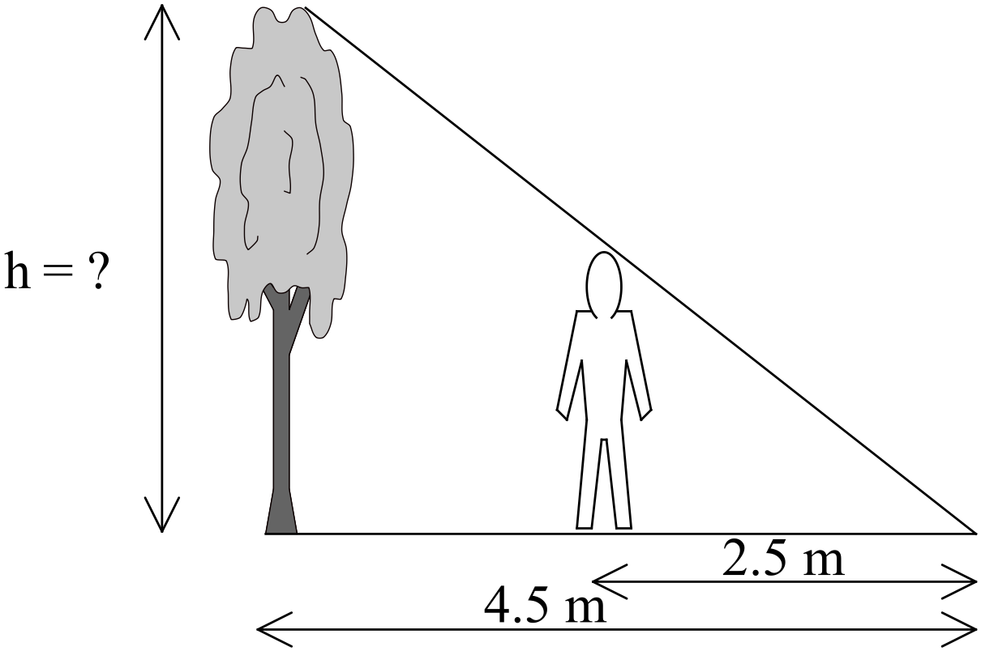

(e) The width of a ladybird is one quarter the size of the one in the diagram.


(i) If the ladybird in the diagram was 3 cm long, how long is a real ladybird? (1)

(ii) If a model this size was made of the ladybird, then it would weigh 1.3 grams.
Estimate the weight of a ladybird. (2)

Question 13 (21 marks)

(a) Find the values of the pronumerals in the diagrams below.
(i) (2)
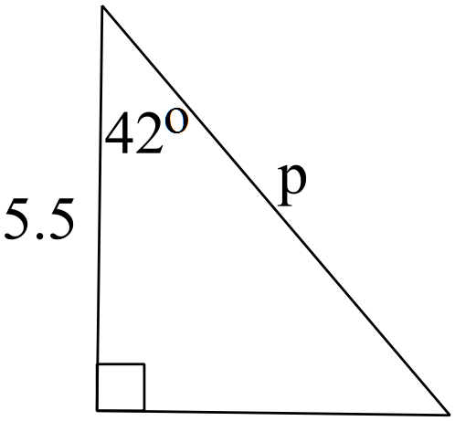

(ii) (2)

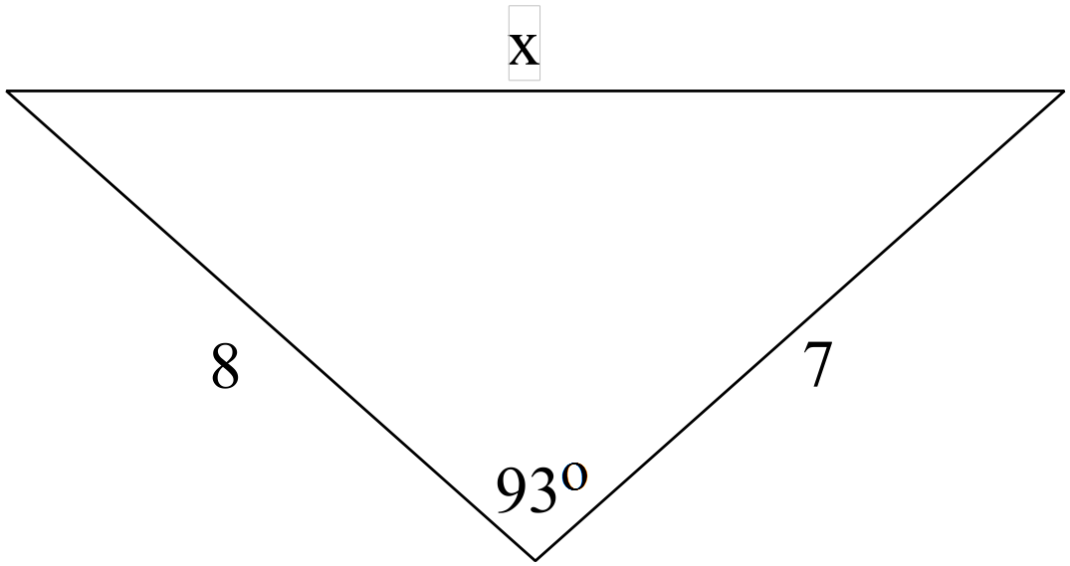

(iii) (3)
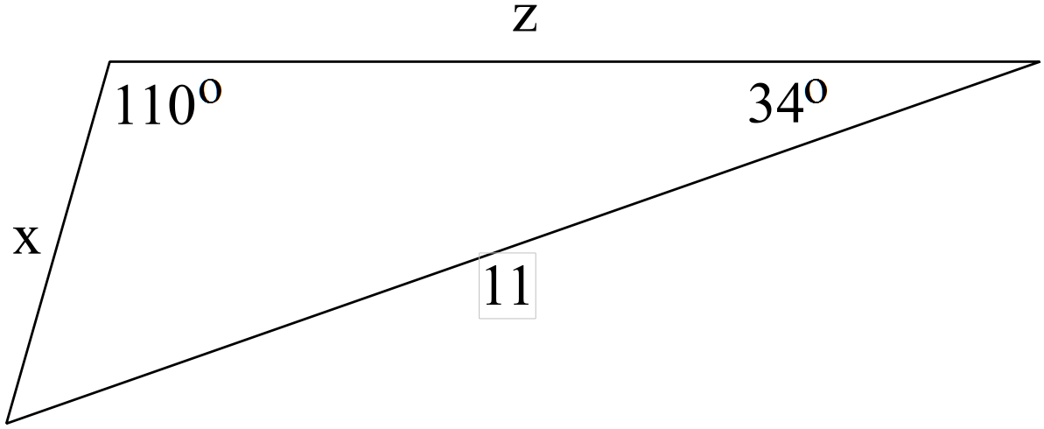

(b) Ken took his small plane on a Sunday outing. He flew 592 km due east
from Perth to Kalgoorlie, landed and had a break.

He then flew 230 km on a bearing of 012º. He then turned back to Perth and flew home.

(i) Draw a diagram of the path of the plane. (3)

(ii) Determine the distance Ken had to fly to arrive back at Perth. (2)

(iii) Determine the direction Ken had to fly to return to Perth. (4)


(c) A 2.2 metre ladder leans against the top of a 1.8 m tall wall.

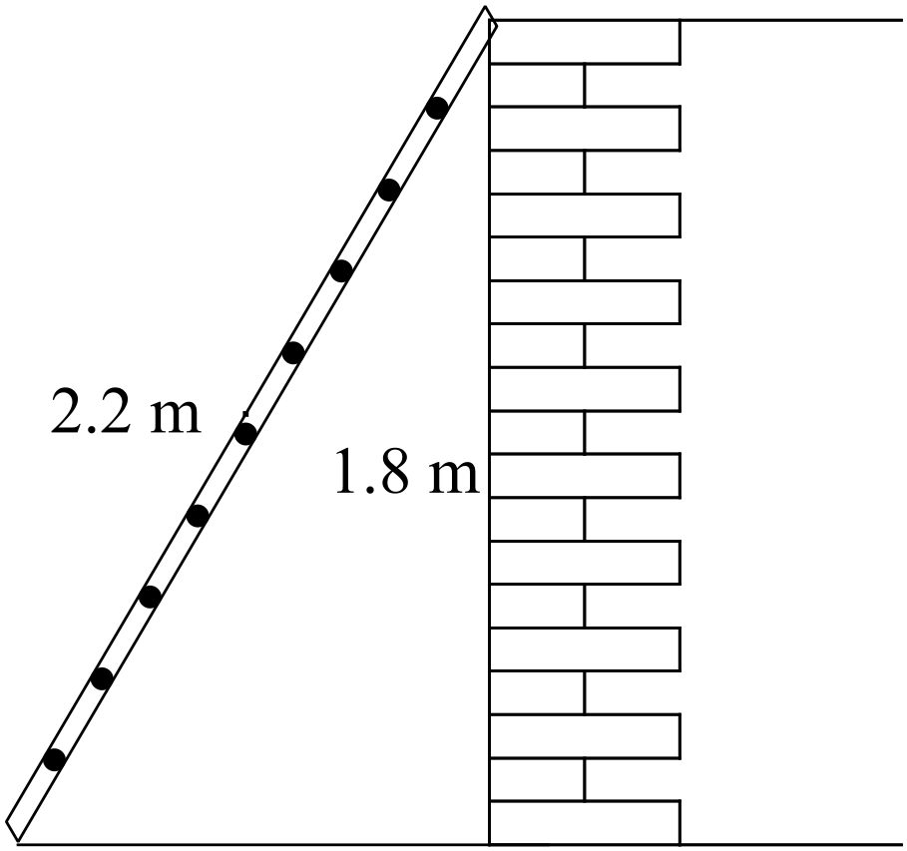

(i) What angle does the ladder make with the ground? (3)

(ii) Use trigonometry to determine how far the base of the ladder is from the wall. (2)

Question 14 (5 marks)

John had a day off healthy food and ordered 3 Big Macs and 4 cans of coke. It cost him $22.43.
His friend Joel, joined John and they watched DVDs all day. Joel bought 2 Big Macs and 5 cans of coke. It cost him $19.62.
How much did the two friends pay for a Big Mac? a can of Coke? (5)

Question 15 (5 marks)
Define the function graphed below.
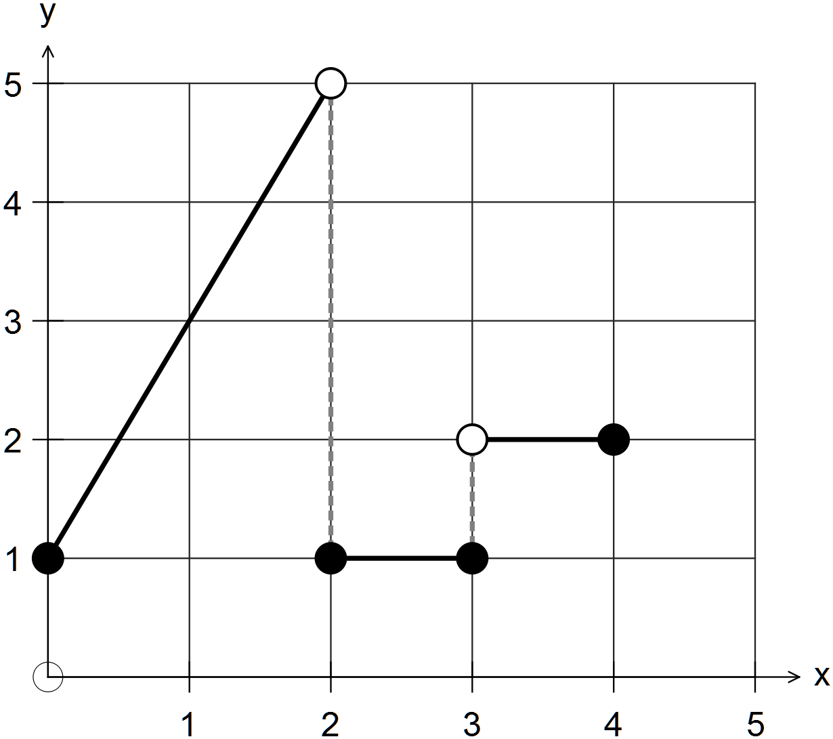

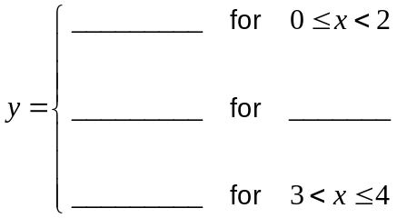 (5)

Question 16 (15 marks)

(a) The height of 60 students in a class is normally distributed with a mean of 1.6 m and a
standard deviation of 5.5 cm.

One of the students is selected at random.

(i) What is the probability that the student weighs less than 1.7 m? (2)

(ii) What is the probability that the student weighs between 1.55 and 1.6 m? (2)

(iii) What is the probability that the student weighs more than than 1.55 m? (2)

(iv) What is the greatest height of the shortest 70% of students? (3)

(b) (i) Jenny and Damon had tests last week.
Jenny earned 85% in her English test and Damon got 76 in his Maths test.

Given the mean of English test was 80% and the standard deviatian was 10%, and
the mean of the Maths test was 70% and the standard deviation was 5%, who did
relatively the better? (4)

(ii) Damon’s friend Pete, got 70% in both the English test and the Maths test.
Which was the better result? (2)

END OF SECTION TWO

